Blockchain-Based Autonomous Notarization System Using National eID Card

Increasing communication technology migrating all government services to E-government where applicants can register for all types of government services online and one such service is Notary service which provide authentication to documents.

All existing notary applications were using single centralized server for storage which can be easily manipulated by server administration by taking bribes. Server manipulation can be done in alteration of notary and there is no direct way for the user to know about such alteration. Sometime hackers can hack and change server data.

To overcome from above issue author of this paper employing Blockchain technology to manage Notary services which will authenticate only notary document and not it’s content. Blockchain has inbuilt support for data encryption and verification which will store each record as block/transaction and associate each block with unique hash code. While storing new blocks it will verify hash code of all previous blocks and if data not tamper then it will result into same hash code and verification get successful, if data alter then result into different hash code and verification get failed.

So above process of Blockchain can make notary services tamper proof and all notary services will be managed by SMART CONTRACTS which will contains function to Register Notary hash on fixed date, delete or view notary key. Smart contract will be designed using SOLIDITY programming and for notary management we have designed following contract

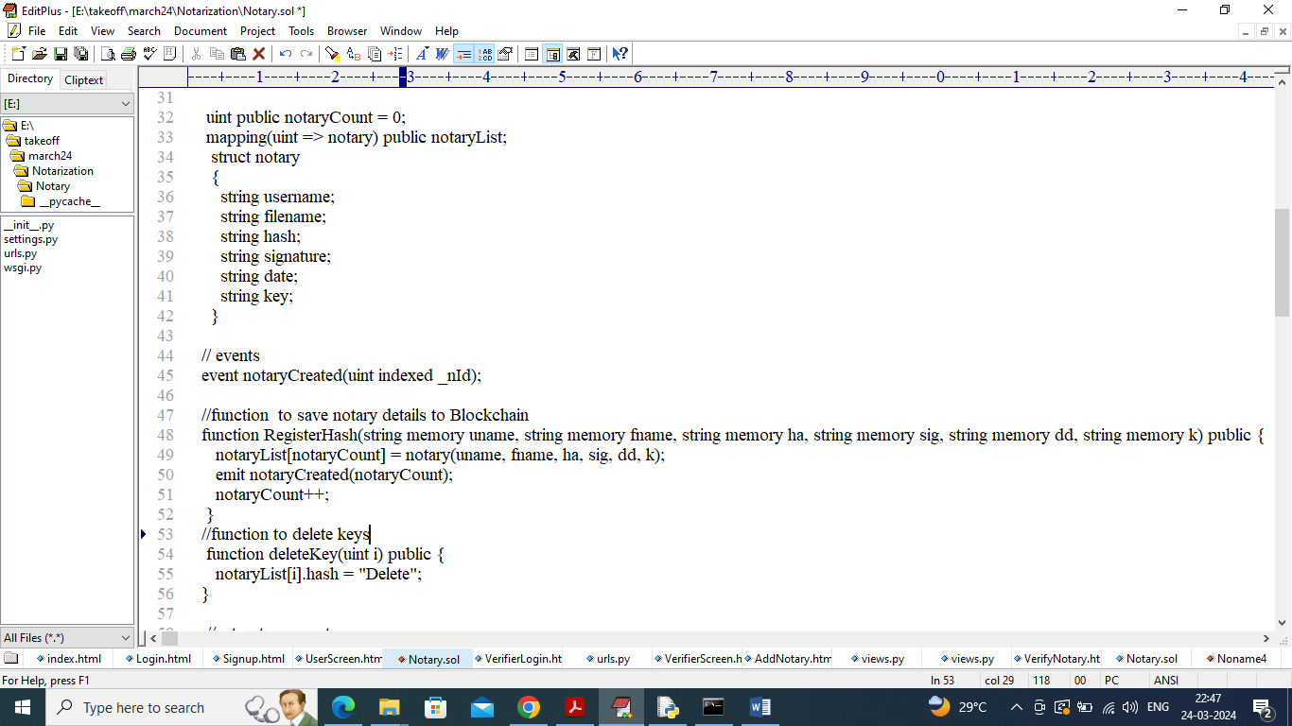

In above screen showing some code from SMART CONTRACT.

User can create notary and then associate notary by using eID card (verification card). Each notary will get hash using eID card and pin no. user and verifier can verify this notary by issuing valid eID card and pin no.

All Notaries will be manage by smart contract which can be run through Ethereum Blockchain and above contract we need to deploy in Ethereum Blockchain by using below steps

1. First go inside ‘hello-eth/node-modules/bin’ folder and then find and double click on ‘runBlockchain.bat’ file to get below screen
2. 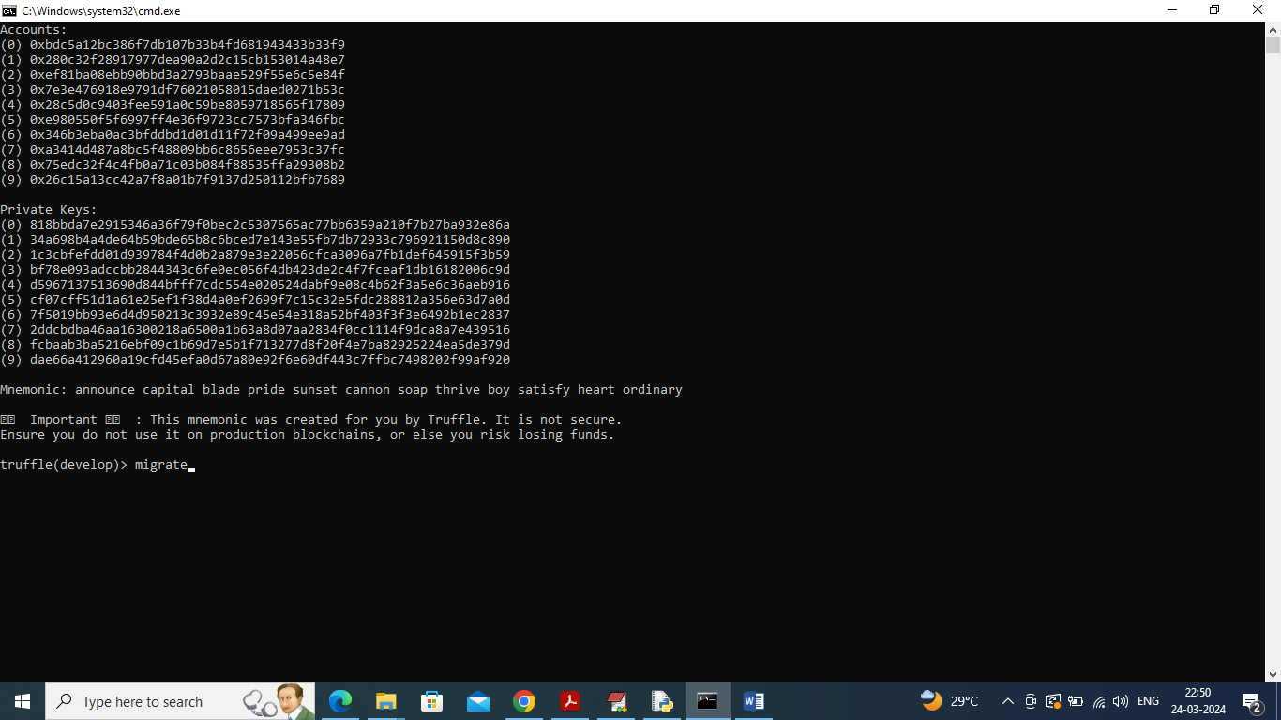
3. In above screen Ethereum started with default account and private keys and now type command as ‘migrate’ and press enter key to deploy ‘Notary’ contract in Ethereum and will get below output
4. 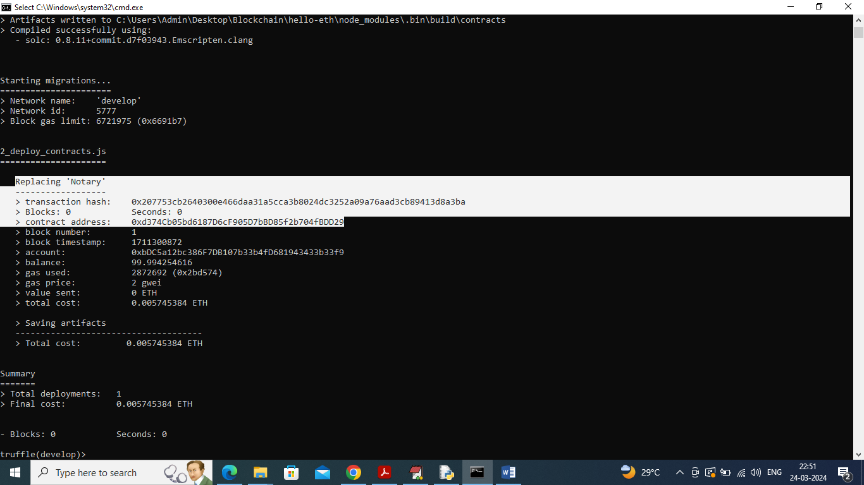
5. In above screen in white colour text can see ‘Notary’ contract deployed and we got contract address also and this address need to specify in python code to save and get notary details from Ethereum Blockchain. In above screen contract deployed and let it running. Whenever you are executing code you need to start above Ethereum tool. In below screen showing python code calling contract using above contract address
6. 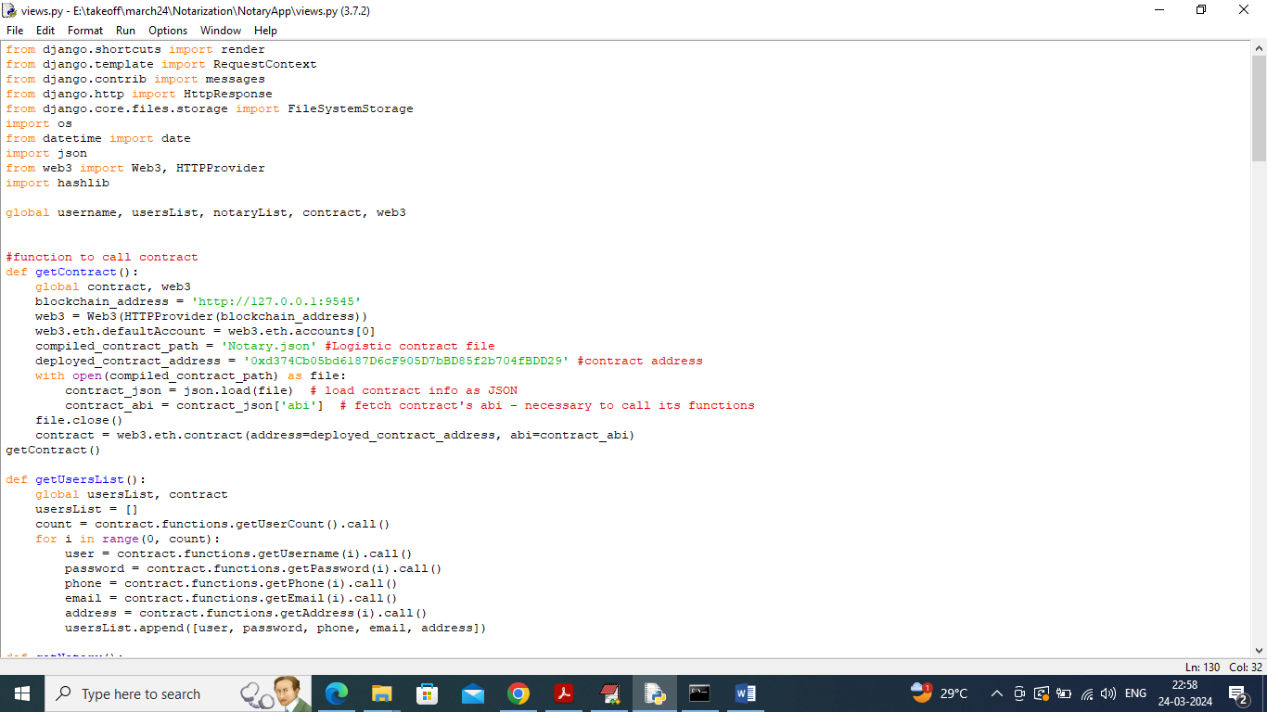
7. In above screen read red colour comments to know about contract calling using contract address

To implement this project we have designed following modules

1. Verifier Login: verifier can login to system using username and password as ‘admin and admin’ and this will consider as government employee. After login verifier can collect eID card and pin no from user and then hash and generate signature and then SMART CONTRACT will verify weather hash and signature valid or not and if valid then verifier can view all details otherwise get ‘Verification failed’ error.
2. New User Sign up: new users can sign up with the application and all details will get saved in Blockchain
3. User Login: user can login with sign up details and after login user will perform below operations
4. Add Notary: user can create notary using pin no and eID file
5. Delete Notary: user can delete any existing notary details and keys
6. View Notary: using this module user can view notary on particular eID and pin no.

SCREEN SHOTS

Double click on ‘runServer.bat’ file to start python server and get below page

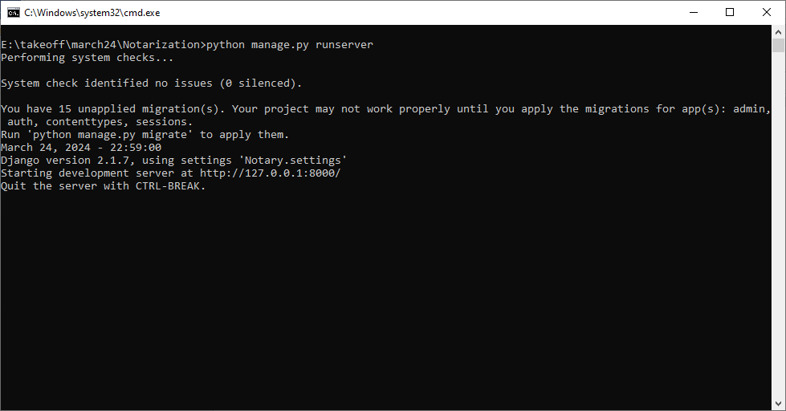

In above screen python server started and now open browser and enter URL as <http://127.0.0.1:8000/index.html> and press enter key to get below page

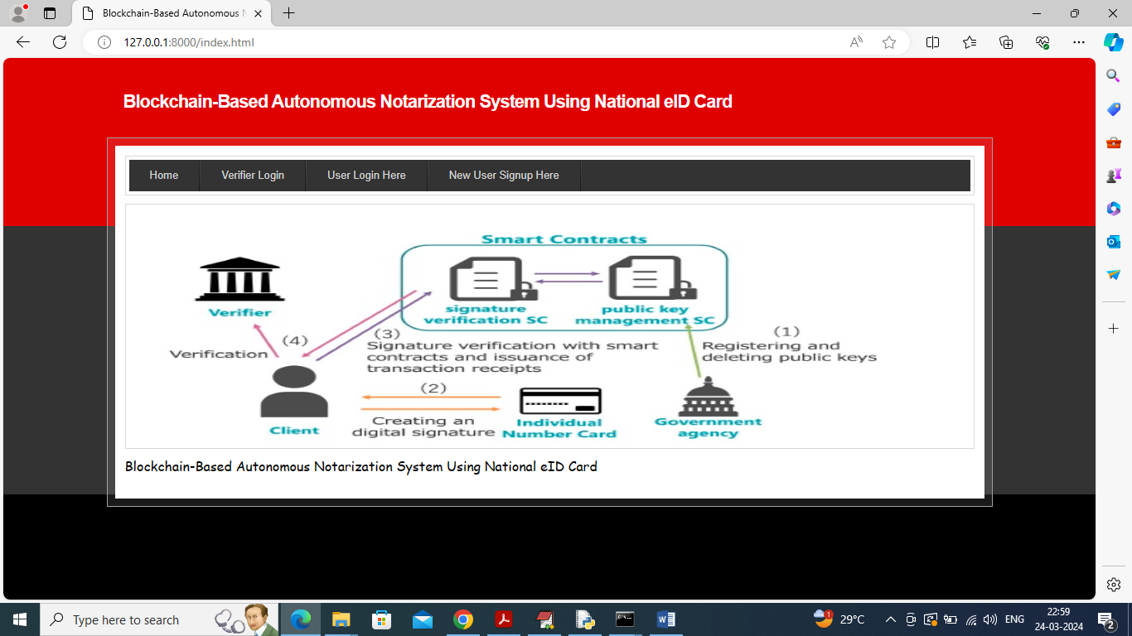

In above screen click on ‘New User Sign up’ link to get below page

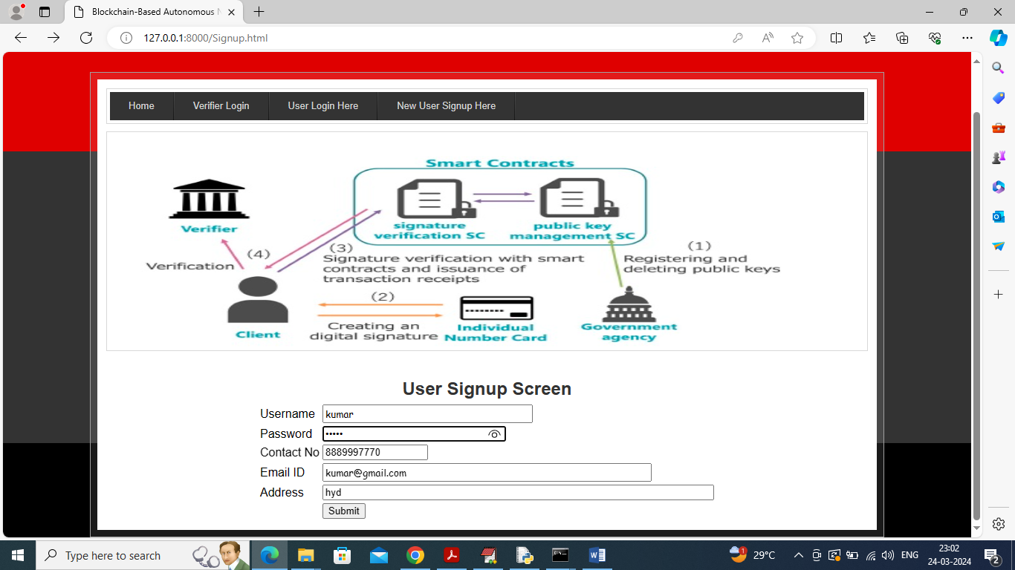

In above screen user is entering sign up details and then press button to get below output

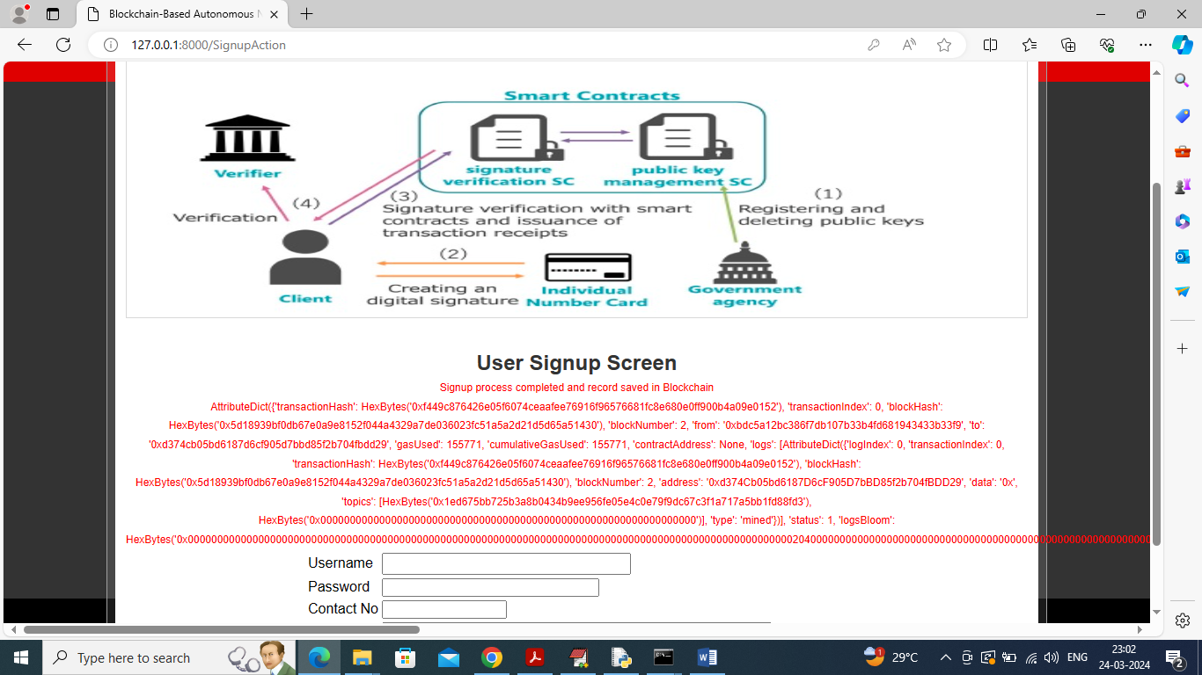

In above screen in red colour text we got transaction receipt from Ethereum and for your understanding purpose we are displaying entire details instead of displaying transaction hash code. In above output we can see block no, transaction hash and many other details. Now click on “User Login” link to get below page

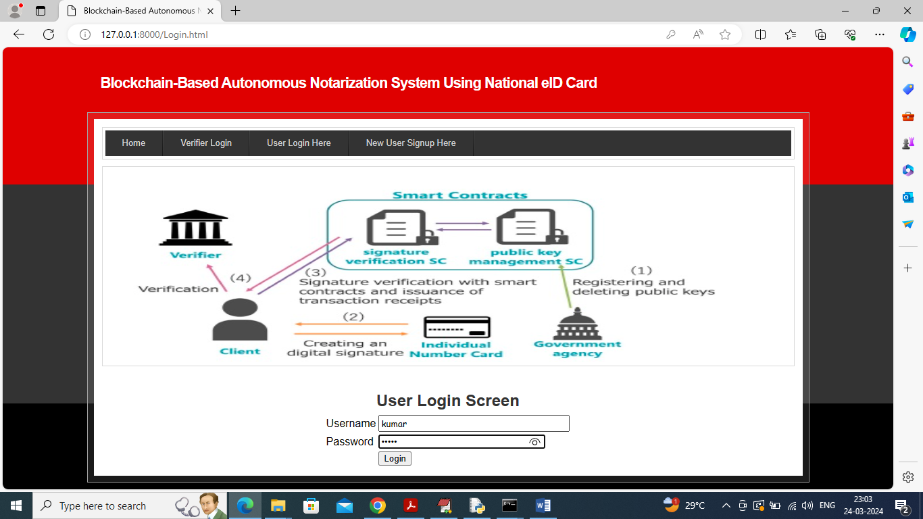

In above screen user is login and after login will get below page

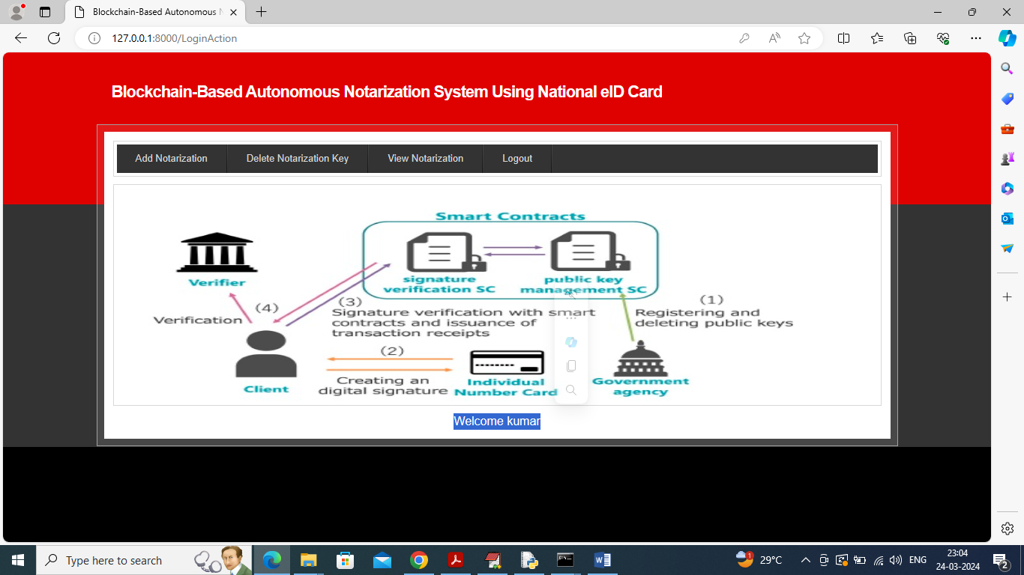

In above screen user can click on ‘Add Notarization’ link to create notary and will get below screen

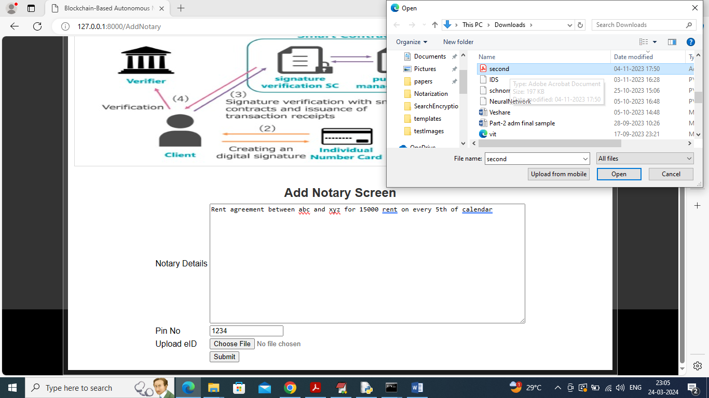

In above screen enter some notary text and then enter pin no and then select some eID document and then click on ‘Open’ and ‘Submit’ button to hash document and save all notary details to Blockchain and will get below output

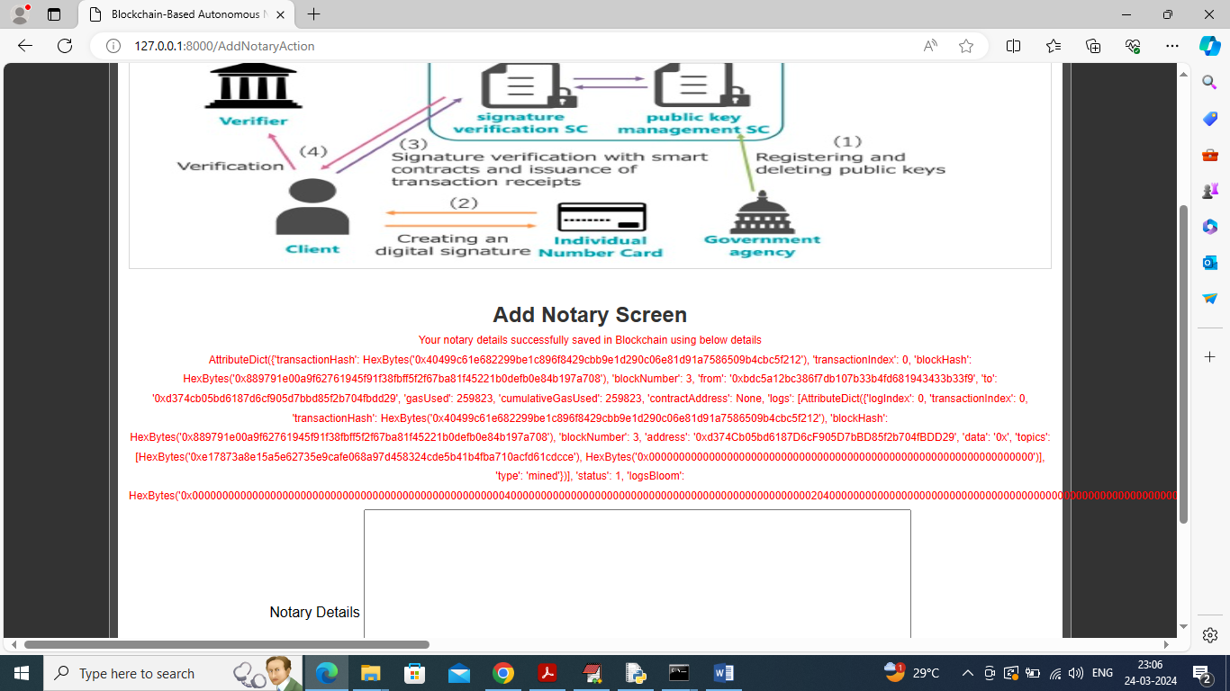

In above screen notary details saved in Blockchain and can see all transaction receipt and now click on ‘View Notary’ link to view all existing created notary details

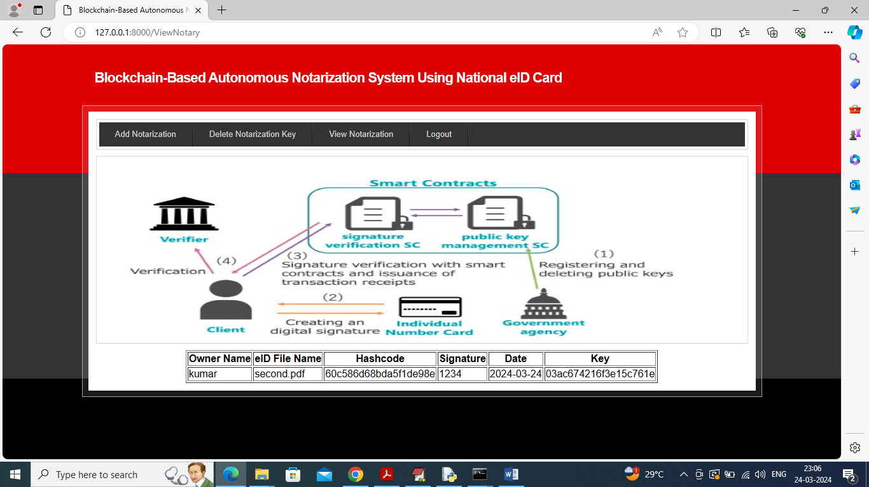

In above screen user can view all notary details along with signature, key hash code and created fixed date. To delete notary and its key then click on ‘Delete Notarization key’ link to get below output

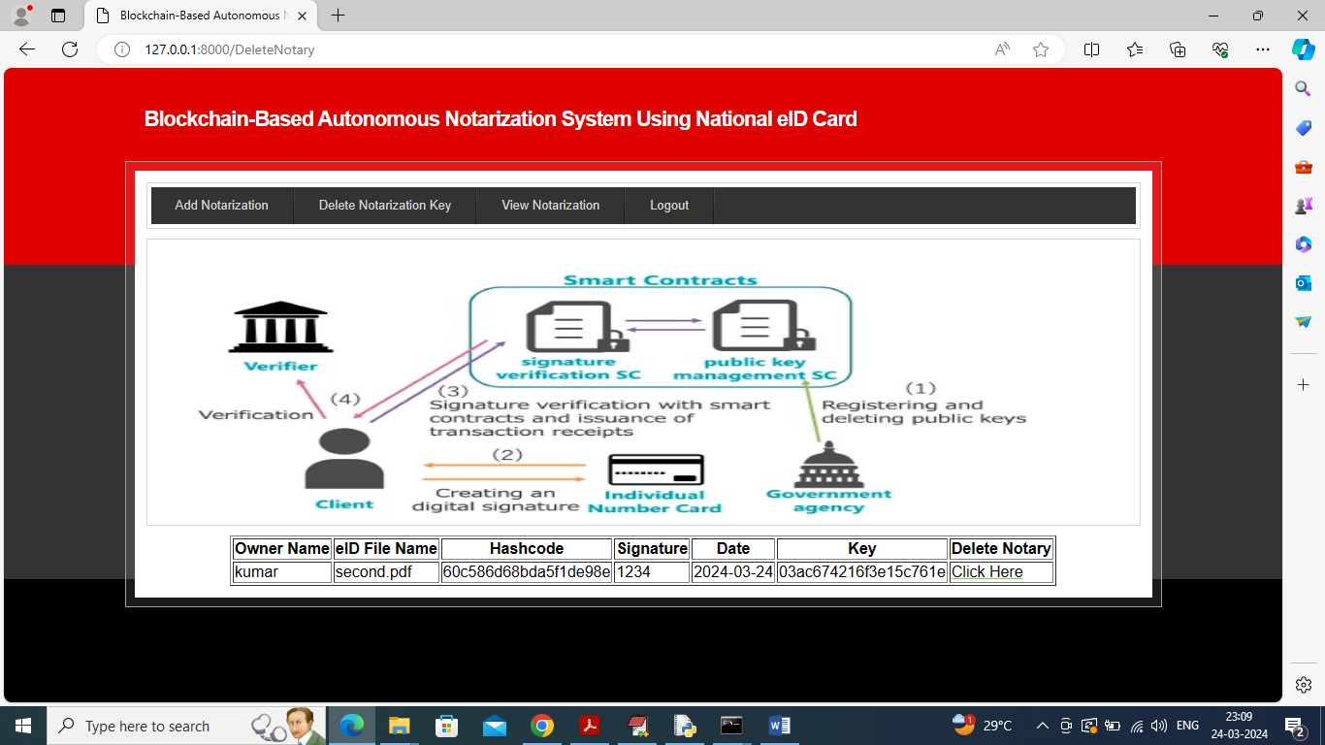

In above screen user can view all notary details and can click on ‘Click Here’ link to delete notary and now logout and login as ‘Verifier’ to verify notary

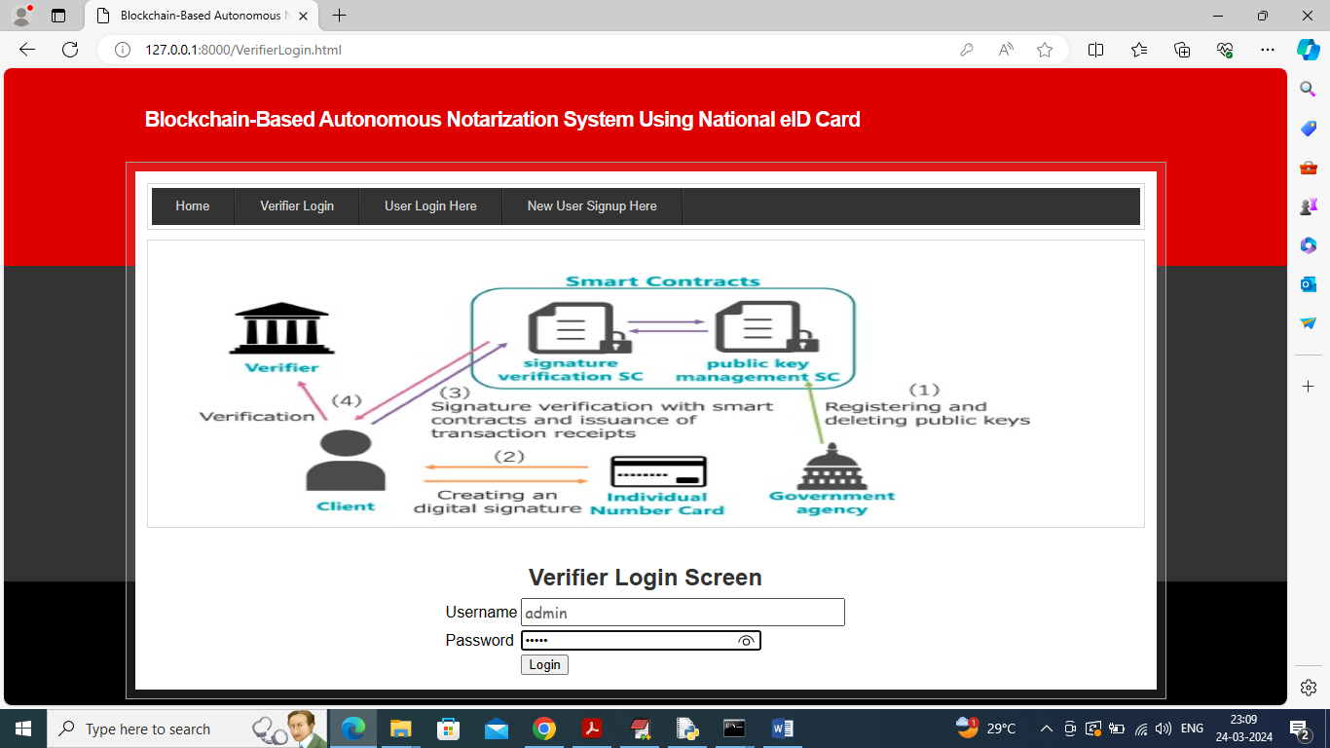

In above screen verifier is login and after login will get below page

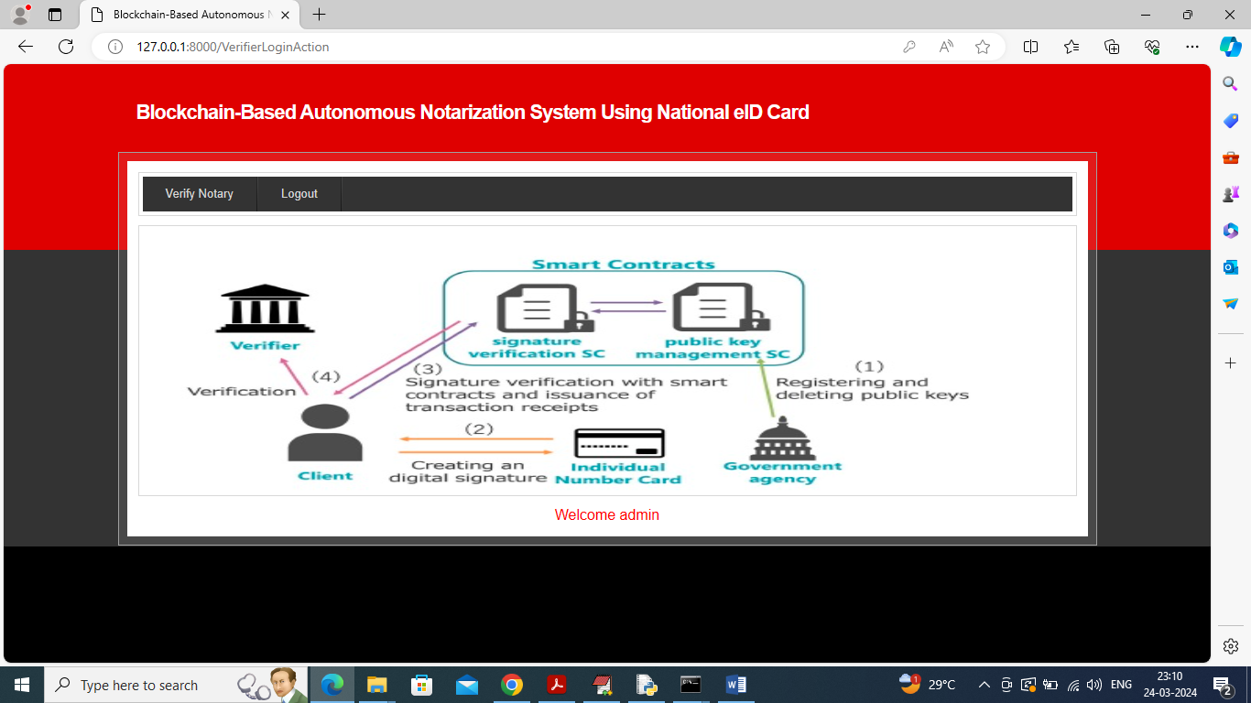

In above screen verifier can click on ‘Verify Notary’ link to get below page

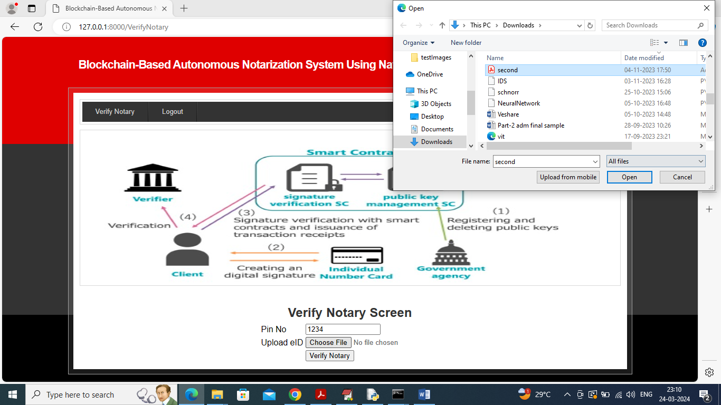

In above screen user has to give correct pin no and eID card to verifier to verify his notary and in above screen I am giving correct details and then press button to get below page

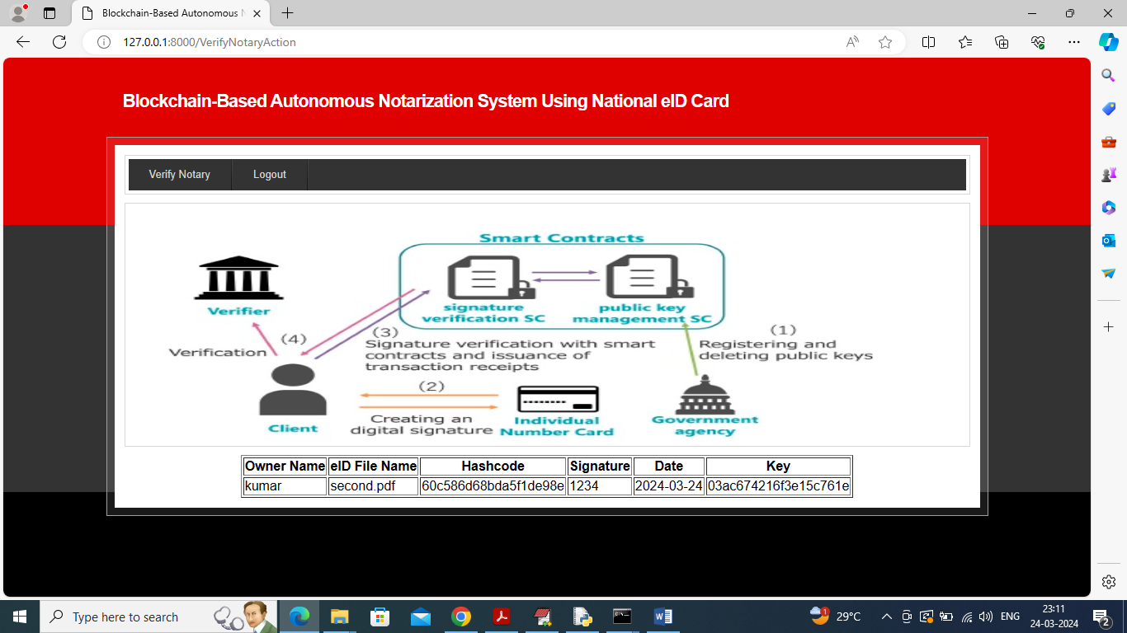

In above screen notary is verified and ‘Verifier’ can view all details as proof and now enter wrong details in below screen

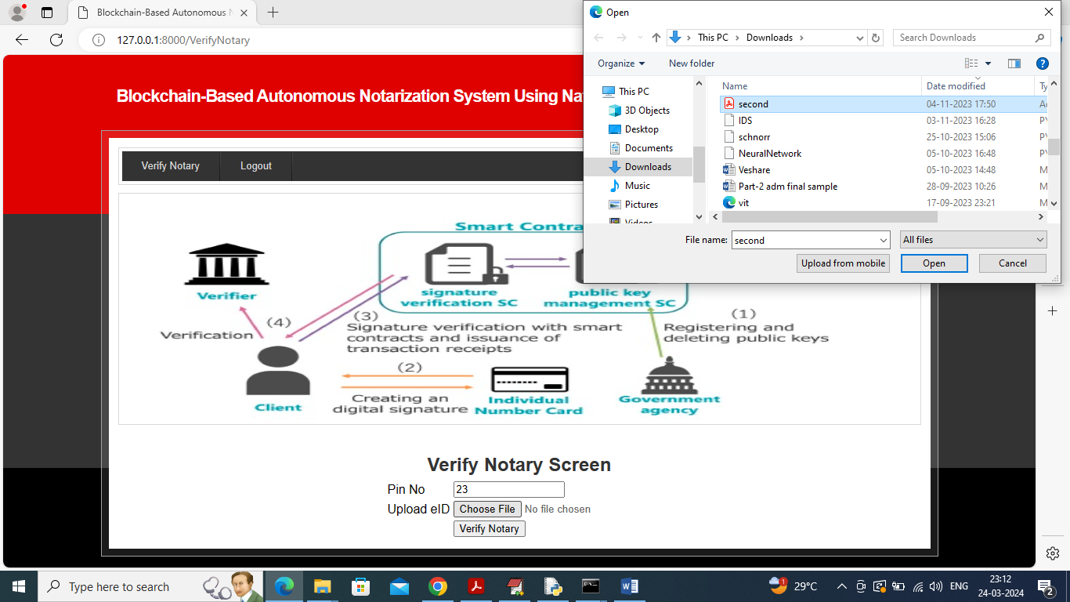

In above screen I am entering wrong pin no and below is the verification result from smart contract

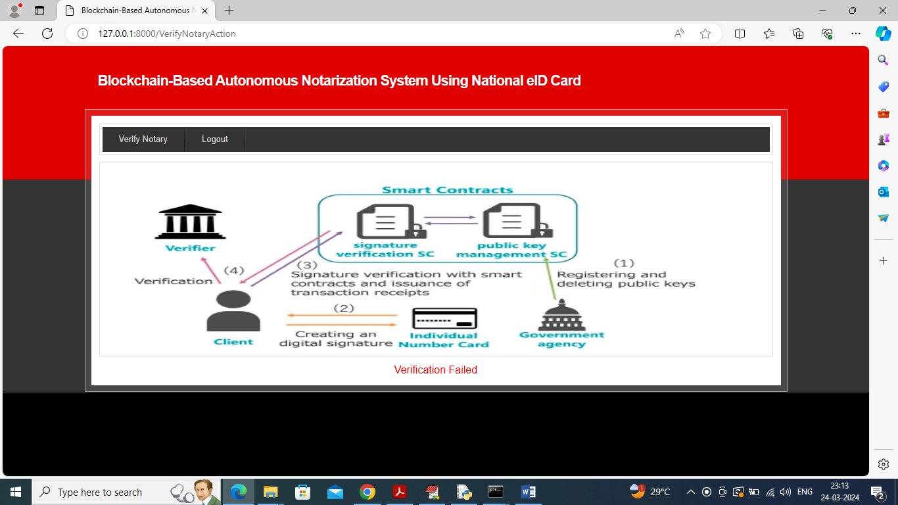

In above screen verification got failed

Similarly by following above screens you can manage all notary services in Blockchain without fearing of alteration.